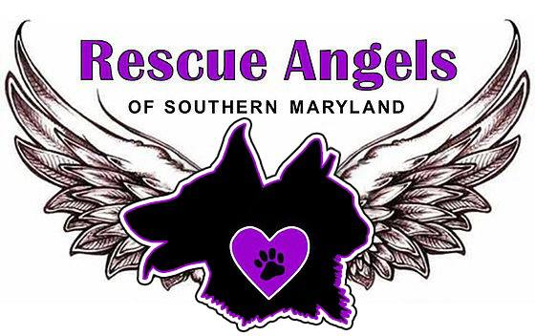

Volunteer Application

Rescue Angels of Southern Maryland (RASM) is a not-for-profit charitable organization funded primarily through donations. Our mission is to change the lives of animals in need by rescuing them from undesirable situations, providing loving homes and any needed medical care, including mandatory spay and neuter. We welcome the participation of those willing to represent our organization in accordance with our mission and philosophies. Volunteers are vital to our success!

Please complete the following and email your completed form to rescueangelssomd@gmail.com
Name

Address

City, State, ZIP

Phone

E-mail

What are you most interested in doing as a RASM volunteer?

Experience, Special Skills, Strengths, and Talents:

____ Clean cages and care for cats at Petco
___ Gardening /Landscaping ___ Writing/Editing
___ Graphic Arts ___ Clerical
___ Painting ___ Carpentry
___ Fundraising ___ Sewing
___ Public Relations ___ Web design
___ Photography ___ Animal Transport
___ Technology ___ Crafts
___ Teaching ___ Marketing
___ TNR/caretaking of feral cats ___ Vet Tech work
___ Volunteer coordination _ __ Special events
___ Event/fundraising coordination ___ Fostering
___ Other-Please describe:

I, (name) ______________________________ confirm that the information provided on this application is correct. I understand the commitment involved and acknowledge that my services are offered at my own risk with no liability to RASM. I agree to adhere to Rescue Angels of Southern Maryland’s policies and carry out my duties as a volunteer effectively.

Signature ____________________________________________________________ Date _______________

RASM Witness _____________________________________________________________________________

